**PYTHON**

**CIA TEST – 4**

**Name:** Deep Das

**Reg No.:** 1841013

**Numpy**

1. **Create a matrix A from 2D list containing elements from 11 to 19.**

Ans.

a = np.array([[11, 12, 13], [14, 15, 16], [17, 18, 19]])

a

**Output:**

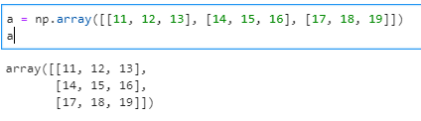

1. **Find the determinant of the matrix**

**Ans.**

print(np.linalg.det(a))

**Output:**

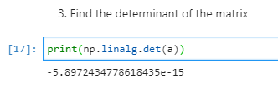

1. **Perform Scalar multiplication on matrix A**

**Ans.**

a * 2

**Output:**

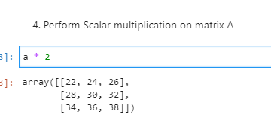

1. **Create one more matrix B (use any builtin function to generate values) of same dimension as matrix A and perform multiplication. Display both matrices, their dimension and the result.**

**Ans.**

b = np.arange(9).reshape(3, 3)

b

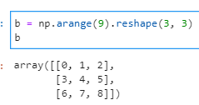

print('First Matrix:\n', a)

print('\nDimension of Matrix a: ',a.shape)

print('\nSecond Matrix:\n',b)

print('\nDimension of Matrix b: ', b.shape)

b.shape

mat_multi = a @ b

print('\nProduct of a and b:\n',mat_multi)

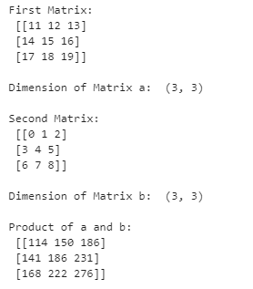

**PANDAS**

1. **Find the missing values and give a report of it.**

**Ans.**

df = pd.read_csv('employees.csv')

df

df.isnull()

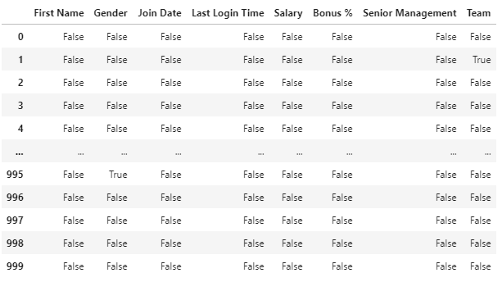

1. **Fetch employee names based on join date**

**Ans.**

col_list = ['First Name', 'Join Date']

names_date = pd.read_csv('employees.csv', usecols=col_list)

names_date

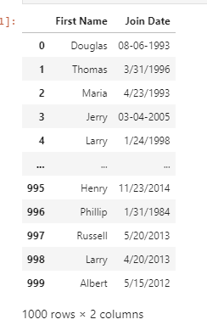

1. **Fetch all the employees having Team = Finance and Salary >= 1,00,000**

**Ans.**

emp_finance = df[(df["Team"] == "Finance") & (df["Salary"] > 100000)]

emp_finance

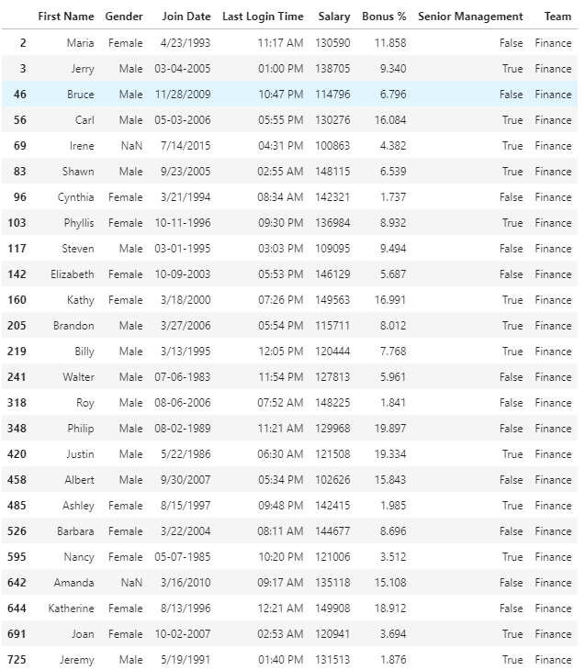

1. **Fetch all the female employees of having Bonus more than 10%.**

**Ans.**

emp_female_bonus = df[(df['Gender'] == 'Female') & (df['Bonus %'] > 10)]

emp_female_bonus

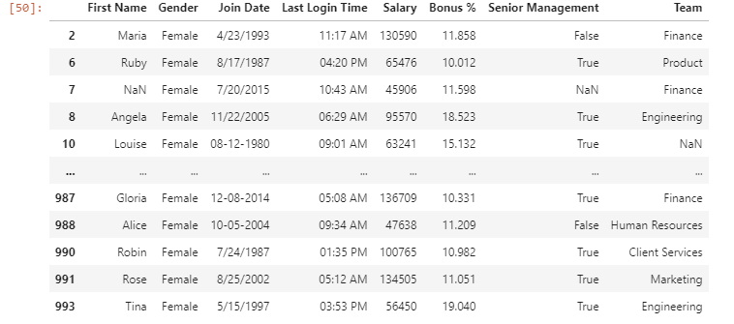

1. **Perform basic statistical analysis on the given dataset using any five statistical functions.**

**Ans.**

print('SUM =\n',df.sum())

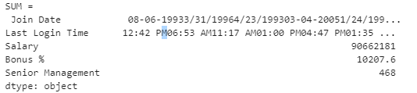

print('Mean=\n',df.mean())

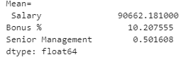

print('Bressel Standard Deviation=\n',df.std())

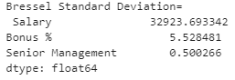

print('Median=\n',df.median())

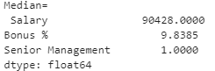

print('Minimum Values=\n',df.min())

